PROJECT FINAL REPORT

Grant Agreement number: 288985
Project acronym: SERSCIDA
Project title: Support for Establishment of National/Regional Social Sciences Data Archives
Funding Scheme: FP7-CSA-SA
Period covered: from 01/01/2012 to 30/06/2014
Name, title and organisation of the scientific representative of the project's coordinator: Ms Lejla Somun-Krupalija, on behalf of Ms Andjela Lalovic, University of Sarajevo, Human Rights Centre
Tel: +387 62 332 912
Fax: +387 33 66 82 51
E-mail: lsk@hrc.unsa.ba
Project website address:
www.serscida.eu

Declaration by the scientific representative of the project coordinator

I, as scientific representative of the coordinator of this project and in line with the obligations as stated in Article II.2.3 of the Grant Agreement declare that:

- The attached periodic report represents an accurate description of the work carried out in this project for this reporting period;
- The project (tick as appropriate) :
has fully achieved its objectives and technical goals for the period;
  - has achieved most of its objectives and technical goals for the period with relatively minor deviations.
  - has failed to achieve critical objectives and/or is not at all on schedule.

- The public website, if applicable
is up to date
  - is not up to date
- To my best knowledge, the financial statements which are being submitted as part of this report are in line with the actual work carried out and are consistent with the report on the resources used for the project (section 3.4) and if applicable with the certificate on financial statement.
- All beneficiaries, in particular non-profit public bodies, secondary and higher education establishments, research organisations and SMEs, have declared to have verified their legal status. Any changes have been reported under section 3.2.3 (Project Management) in accordance with Article II.3.f of the Grant Agreement.

Name of scientific representative of the Coordinator: ...Lejla Somun-Krupalija.....

Date: 24/08/2014.

For most of the projects, the signature of this declaration could be done directly via the IT reporting tool through an adapted IT mechanism and in that case, no signed paper form needs to be sent

4.1 Final publishable summary report

This section must be of suitable quality to enable direct publication by the Commission and should preferably not exceed 40 pages. This report should address a wide audience, including the general public.

The publishable summary has to include 5 distinct parts described below:

4.1.1. An executive summary (not exceeding 1 page).

4.1.2. A summary description of project context and objectives (not exceeding 4 pages).

4.1.3. A description of the main S&T results/foregrounds (not exceeding 25 pages),

4.1.4. The potential impact (including the socio-economic impact and the wider societal
implications of the project so far) and the main dissemination activities and exploitation of
results (not exceeding 10 pages).

4.1.5. The address of the project public website, if applicable as well as relevant contact details. Furthermore, project logo, diagrams or photographs illustrating and promoting the work of the project (including videos, etc…), as well as the list of all beneficiaries with the corresponding contact names can be submitted without any restriction.

4.2 Use and dissemination of foreground

A plan for use and dissemination of foreground (including socio-economic impact and target groups for the results of the research) shall be established at the end of the project. It should, where appropriate, be an update of the initial plan in Annex I for use and dissemination of foreground and be consistent with the report on societal implications on the use and dissemination of foreground (section 4.3 – H).
The plan should consist of:

􀂃 Section A
This section should describe the dissemination measures, including any scientific publications
relating to foreground. Its content will be made available in the public domain thus
demonstrating the added-value and positive impact of the project on the European Union.

􀂃 Section B
This section should specify the exploitable foreground and provide the plans for exploitation. All these data can be public or confidential; the report must clearly mark non-publishable
(confidential) parts that will be treated as such by the Commission. Information under Section B that is not marked as confidential will be made available in the public domain thus
demonstrating the added-value and positive impact of the project on the European Union.

Section A (public)
This section includes two templates

􀂃 Template A1: List of all scientific (peer reviewed) publications relating to the foreground of the project.

􀂃 Template A2: List of all dissemination activities (publications, conferences, workshops, web sites/applications, press releases, flyers, articles published in the popular press, videos, media briefings, presentations, exhibitions, thesis, interviews, films, TV clips, posters).
These tables are cumulative, which means that they should always show all publications and activities from the beginning until after the end of the project. Updates are possible at any time.

TEMPLATE A1: LIST OF SCIENTIFIC (PEER REVIEWED) PUBLICATIONS, STARTING WITH THE MOST IMPORTANT ONES
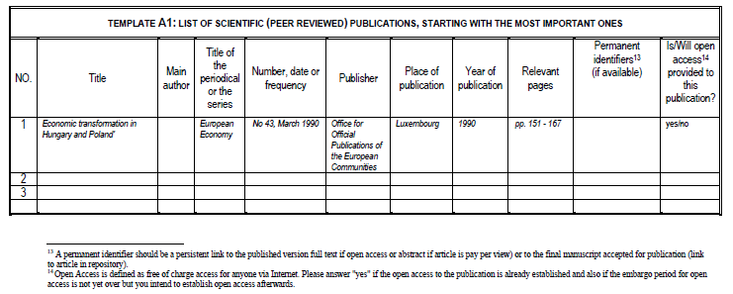

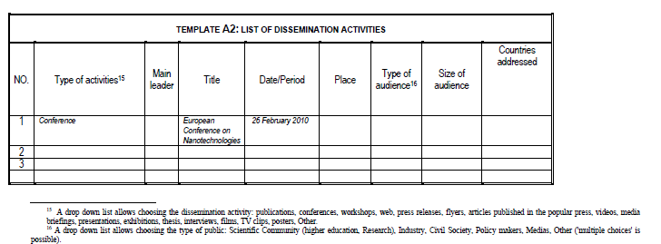

Section B (Confidential¹⁷ or public: confidential information to be marked clearly)

Part B1

The applications for patents, trademarks, registered designs, etc. shall be listed according to the template B1 provided hereafter.
The list should, specify at least one unique identifier e.g. European Patent application reference. For patent applications, only if applicable, contributions to standards should be specified. This table is cumulative, which means that it should always show all applications from the beginning until after the end of the project.

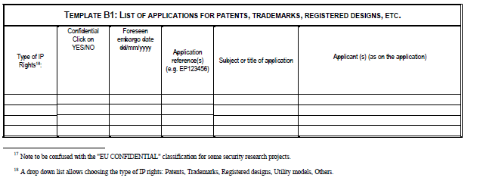

Part B2
Please complete the table hereafter:
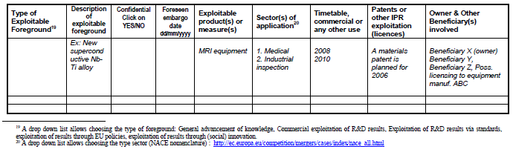

In addition to the table, please provide a text to explain the exploitable foreground, in particular:

Its purpose
How the foreground might be exploited, when and by whom
IPR exploitable measures taken or intended
Further research necessary, if any
Potential/expected impact (quantify where possible)

4.3 Report on societal implications

Replies to the following questions will assist the Commission to obtain statistics and
indicators on societal and socio-economic issues addressed by projects. The questions are
arranged in a number of key themes. As well as producing certain statistics, the replies will
also help identify those projects that have shown a real engagement with wider societal issues,
and thereby identify interesting approaches to these issues and best practices. The replies for
individual projects will not be made public.

see tables in Guidance Notes on Project Reporting, pp. 29-35.

4. FINAL REPORT ON THE DISTRIBUTION OF THE
EUROPEAN UNION FINANCIAL CONTRIBUTION

This report shall be submitted to the Commission within 30 days after receipt of the final
payment of the European Union financial contribution.

Report on the distribution of the European Union financial contribution
between beneficiaries

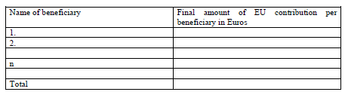

Usually the contact person of the coordinator as specified in Art. 8.1. of the Grant Agreement.
The home page of the website should contain the generic European flag and the FP7 logo which are available in electronic format at the Europa website (logo of the European flag: http://europa.eu/abc/symbols/emblem/index_en.htm logo of the 7th FP: http://ec.europa.eu/research/fp7/index_en.cfm?pg=logos). The area of activity of the project should also be mentioned.
If either of these boxes below is ticked, the report should reflect these and any remedial actions taken.

